Finding Adjusted values:

Given info:
Size: 18x18 Grade: Select Structural
Speices: douglas fir-larch, douglas fir, western larch
Load Duration: live
Mouister: True
Temprature: 100≤T<125
Incised: True
Repetitive member: True
Flat use: True
length between support: 30.0 ft
Support: cantilever
Load: concentrated load at center
Bearing Length: 17.5 in
Math done:
CF math:
d>12 17.5>12
((12/d_act)**(1/9) ((12/17.5)**(1/9) = 0.959
CL math:
d≤b 18≤18 therefore CL = 1
Cp math:
Assuming Ke=1
le1 = length/d 30.0*12/17.5 = 20.571
le2 = length/b 30.0*12/17.5 = 20.571
le = 20.571
Fc*=1000.0*1.0*1.0*0.9*1.0*0.8 = 586.04
E_min' = 580000.0*1.0*1.0*0.9*1.0*1.0*1.0*0.95*1.0*1.0*1.0*1.0 = 495900.0 psi
FcE = 0.822*Emin'/(le/d)^2 0.822*495900.0/20.571428571428573^2 = 963.246
F = FcE/Fc* 963.246/586.04 = 1.644
Cp = (1+F)/1.6-√(((1+F)/1.6)^2-F/0.8) (1+1.644)/1.6-√(((1+1.644)/1.6)^2-1.644/0.8) = 0.83
CT math:
Assuming CT = 1
Cb math:
lb = 17.5 ≥ 6 There for Cb=1
Fb = 1500.0*1.0*1.0*0.7*1.0*0.959*1.0*0.8*1.15*1.0*1.0*1.0 = 926.394 psi
Ft = 1000.0*1.0*1.0*0.9*1.0*1.0*1.0*0.8*1.0*1.0*1.0*1.0 = 720.0 psi
Fv = 170.0*1.0*1.0*0.7*1.0*1.0*1.0*0.8*1.0*1.0*1.0*1.0 = 95.2 psi
Fc⊥ = 625.0*1.0*0.67*0.7*1.0*1.0*1.0*1.0*1.0*1.0*1.0*1.0 = 293.125 psi
Fc = 1150.0*1.0*0.91*0.7*1.0*1.0*1.0*0.8*1.0*0.8304111302052627*1.0*1.0 = 486.654 psi
E = 1600000.0*1.0*1.0*0.9*1.0*1.0*1.0*0.95*1.0*1.0*1.0*1.0 = 1368000.0 psi
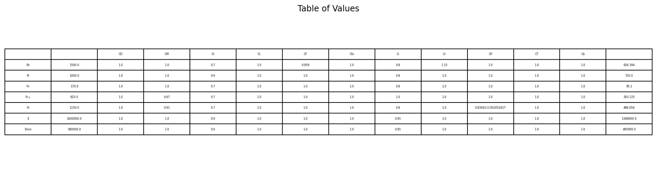
Emin = 580000.0*1.0*1.0*0.9*1.0*1.0*1.0*0.95*1.0*1.0*1.0*1.0 = 495900.0 psi

$$Cp math:$$
$$Assuming Ke=1$$
$$le1 =\frac{length}{d} 30.0*\frac{12}{17.5}= 20.571$$
$$le2 =\frac{length}{b} 30.0*\frac{12}{17.5}= 20.571$$
$$le = 20.571$$
$$Fc*=1000.0*1.0*1.0*0.9*1.0*0.8 = 586.04$$
$$E_{min}^{'}= 580000.0*1.0*1.0*0.9*1.0*1.0*1.0*0.95*1.0*1.0*1.0*1$$
$$= 495900.0 psi$$
$$F_{cE}= 0.822*\frac{Emin^{'}}{{\left(\frac{le}{d}\right)}^{2}} 0.822*\frac{495900.0}{{20.571428571428573}^{2}}= 963.246$$
$$F =\frac{FcE}{Fc}* \frac{963.246}{586.04}= 1.644$$
$$Cp =\frac{1+F}{1.6}-\sqrt{{\left(\frac{1+F}{1.6}\right)}^{2}-\frac{F}{0.8}} \frac{1+1.644}{1.6}-\sqrt{{\left(\frac{1+1.644}{1.6}\right)}^{2}-\frac{1.644}{0.8}}= 0.83$$

